Bug_01:
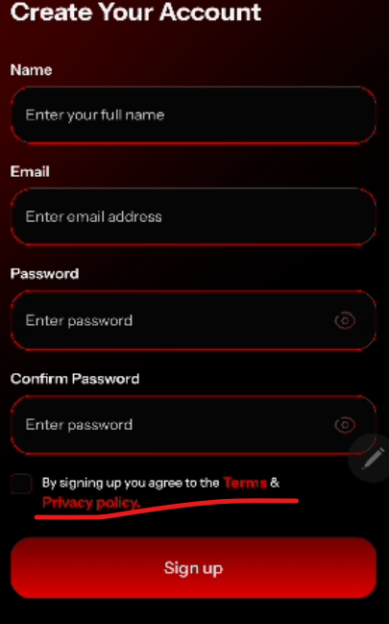
Should be in 1 line
Bug_02:
User enters registration info but gets stuck at phone verification due to a wrong number. When trying again with the same email, the app says "email already registered" even though registration was never completed.
Bug_03:
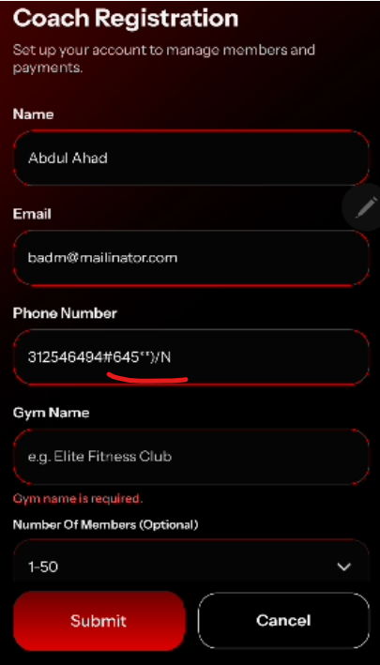
It accept special characters and symbols

Bug_04:
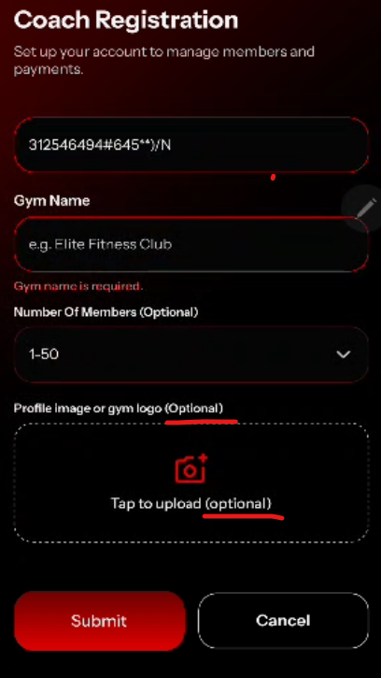
Optional word should be remove from Tap to upload
Bug_05:

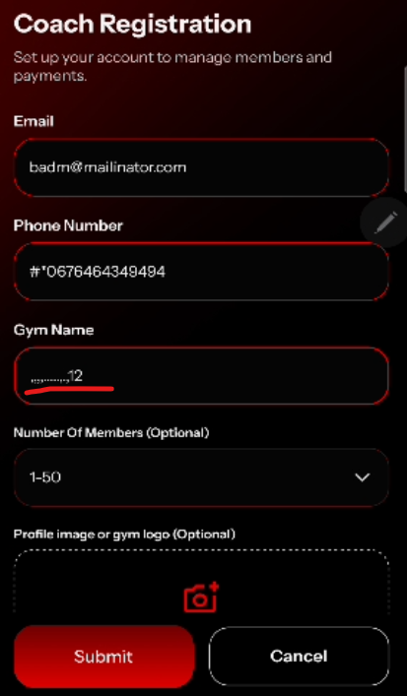
GymName field accept special characters and symbols
Bug_06:

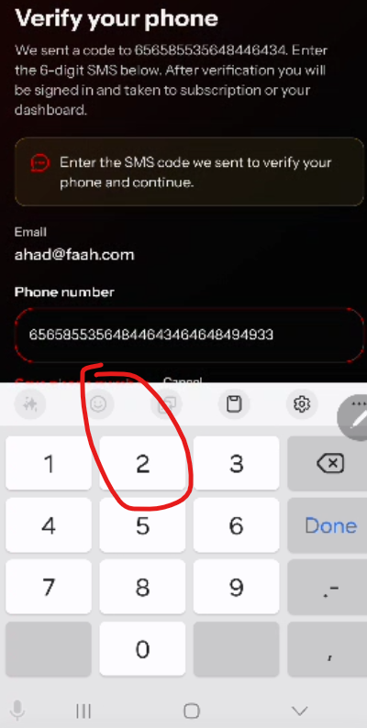
6-digit code is not visible when keypad opens.

Bug_07:
When click back from verify your phone to change any information, it redirects to login page instead of coach registration page with already filled fields.

Bug_08:
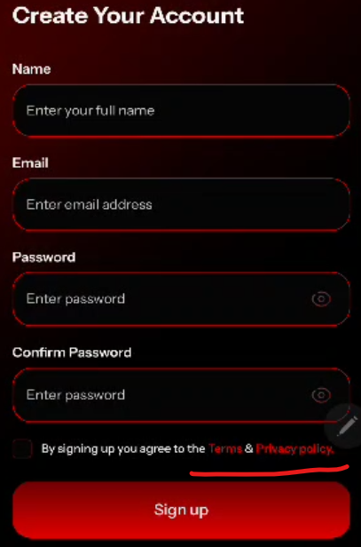
Clicking on "Terms & Privacy policy" clears all the filled information from the form fields. This should not happen. The link should open separately without resetting the form data.
Bug_09:
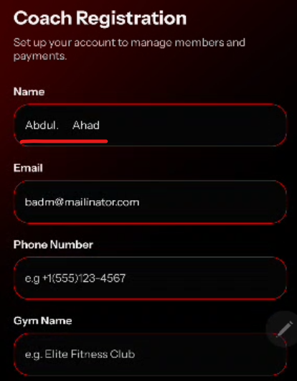
Name field accept . and extra spaces

